Graduate Student Project
Your job is to create a website that allows us to update statistics about the expenses in each US state and to view charts about these state expenses.
General Layout
On the top of your website, you should have two menu options:
- Edit State
- Generate Chart
Clicking the respective option will render that option on the page, with the menu at the top. By default, Edit State is selected.
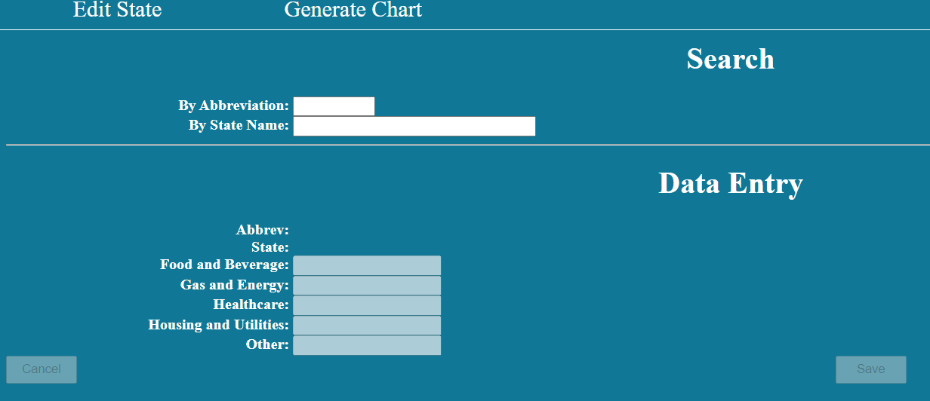
Hovering over a menu option will change the color of the menu option:

The webpage is to have a background color of #107896. The font color is white. The hover color is a yellow background with blue text. Error messages are pink.
Edit State
The edit state page is divided into two parts- a search part and a data entry part. There are two options in Search- By Abbreviation and By State Name.
The Save button is disabled until all the fields are filled correctly.
All the editable fields should only accept numbers. None of the editable fields should allow a negative or blank number.
None of the information is saved until the Save button is pressed.
If the Cancel button is pressed, the system prompts the user if he/she wants to cancel. If so, the data entry part blanks and the user is returned to search.
If the save button is pressed, the system prompts the user if he/she wants to save. If so, the data is saved, the data entry part blanks and the user is returned to search.
The user can also do a search by name. Entering part of the name will reveal a list of states that match that search.
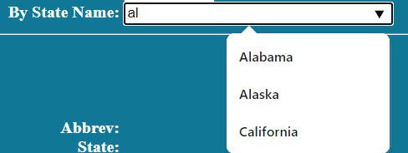
If a user keys in a state name that does not exist, the system reports an error.
Generate Chart
When generate chart is pressed, the user is greeted with the following screen:
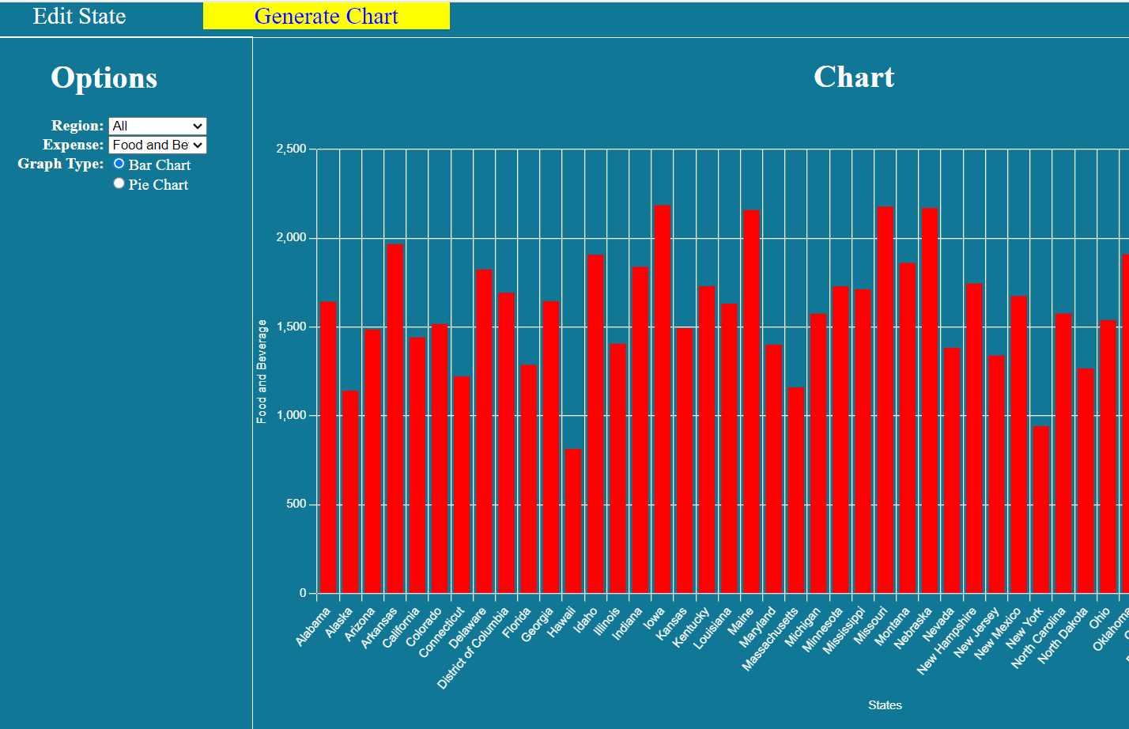

Chart options are presented as a sidebar. There are three options:
- The region to graph
- The expense to graph
- Whether a bar or pie chart is to be graphed.
By default, All, food and beverage and bar are selected and the respective chart is displayed.
Clicking on any of the options automatically generates a new graph.
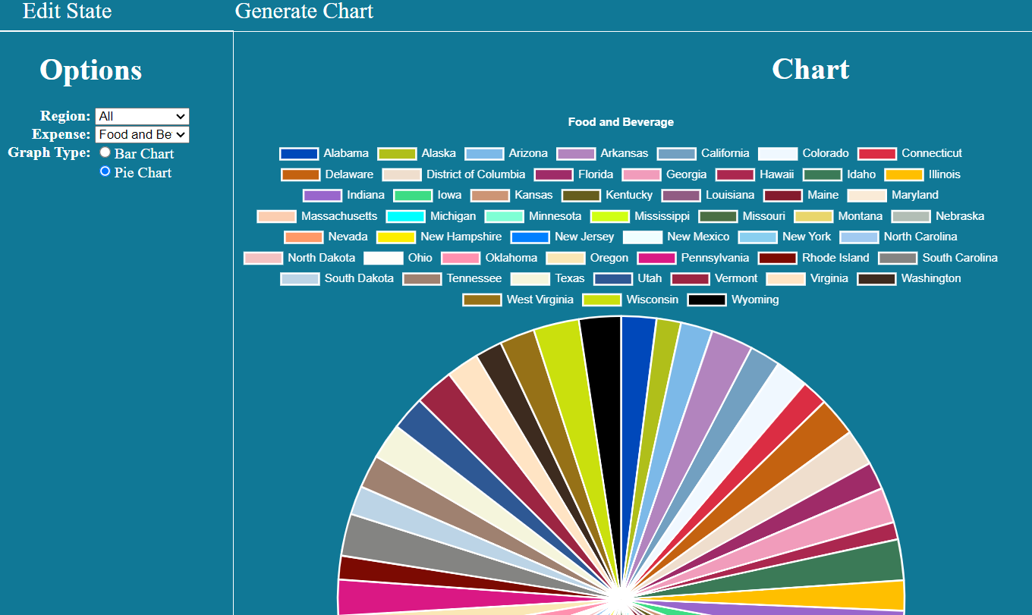
The options for region is:
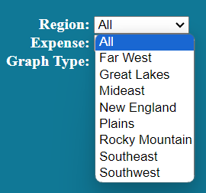

Some useful queries are:
select statename,amount as stat
from states inner join stateexpense
on states.abbrev=stateexpense.abbrev
where expensecode=<expense code>
order by statename

select statename,amount as stat
from states inner join stateexpense
on states.abbrev=stateexpense.abbrev
where expensecode=<expense code>
and region=<region>
order by statename

update stateexpense
set amount=<amount>
where abbrev=<abbrev>
and expensecode=<expensecode>

select states.abbrev, statename, expensecode,amount
from states inner join stateexpense
on states.abbrev=stateexpense.abbrev
where states.abbrev=<abbrev>
order by expensecode

select states.abbrev, statename, expensecode,amount
from states inner join stateexpense
on states.abbrev=stateexpense.abbrev
where statename=<state>
order by expensecode
select distinct region
from states
where region<>'Territory'
order by region
select abbrev,statename
from states
where region<>'Territory'
order by statename
select expensecode,expensename
from stateexpensecat
order by expensecode

Help With Charts
You will need a lot of colors for the pie chart. These are more colors than you will need:
'#0048BA','#B0BF1A','#7CB9E8','#B284BE','#72A0C1','#F0F8FF','#DB2D43','#C46210','#EFDECD','#9F2B68','#F19CBB','#AB274F','#3B7A57','#FFBF00','#9966CC','#3DDC84','#CD9575','#665D1E','#915C83','#841B2D','#FAEBD7','#FBCEB1','#00FFFF','#7FFFD4','#D0FF14','#4B6F44','#E9D66B','#B2BEB5','#FF9966','#FDEE00','#007FFF','#F0FFFF','#89CFF0','#A1CAF1','#F4C2C2','#FEFEFA','#FF91AF','#FAE7B5','#DA1884','#7C0A02','#848482','#BCD4E6','#9F8170','#F5F5DC','#2E5894','#9C2542','#FFE4C4','#3D2B1F','#967117','#CAE00D','#000000','#3D0C02','#54626F','#3B3C36','#BFAFB2','#FFEBCD','#A57164','#318CE7','#ACE5EE','#660000','#0000FF','#1F75FE','#0093AF','#0087BD','#0018A8','#333399','#A2A2D0','#6699CC','#5DADEC','#126180','#8A2BE2','#5072A7','#3C69E7','#DE5D83','#79443B','#E3DAC9','#CB4154','#D891EF','#FFAA1D','#CD7F32','#AF6E4D','#7BB661','#FFC680','#800020','#DEB887','#A17A74','#CC5500','#E97451','#8A3324','#BD33A4','#702963','#5F9EA0','#91A3B0','#006B3C','#ED872D','#A67B5B','#4B3621','#A3C1AD','#C19A6B','#EFBBCC','#FFFF99','#FFEF00','#E4717A','#C41E3A','#00CC99','#960018','#D70040','#FFA6C9','#B31B1B','#56A0D3','#ED9121','#703642','#C95A49','#ACE1AF','#B2FFFF','#DE3163','#007BA7','#2A52BE','#6D9BC3','#1DACD6','#F7E7CE','#F1DDCF','#36454F','#E68FAC','#80FF00','#FFB7C5','#954535','#E23D28','#DE6FA1','#AA381E','#856088','#FFB200','#7B3F00','#D2691E','#98817B','#E34234','#CD607E','#E4D00A','#9FA91F','#7F1734','#6F4E37','#B9D9EB','#F88379','#8C92AC','#B87333','#DA8A67','#AD6F69','#CB6D51','#996666','#FF3800','#FF7F50','#F88379','#893F45','#FBEC5D','#6495ED','#FFF8DC','#2E2D88','#FFF8E7','#81613C','#FFBCD9','#FFFDD0','#DC143C','#9E1B32','#F5F5F5','#00FFFF','#00B7EB','#58427C','#FFD300','#F56FA1','#654321','#5D3954','#008B8B','#536878','#B8860B','#006400','#1A2421','#BDB76B','#483C32','#543D37','#8B008B','#556B2F','#FF8C00','#9932CC','#301934','#8B0000','#E9967A','#8FBC8F','#3C1414','#8CBED6','#483D8B','#2F4F4F','#177245','#00CED1','#9400D3','#555555','#DA3287','#FAD6A5','#B94E48','#004B49','#FF1493','#FF9933','#00BFFF','#4A646C','#7E5E60','#1560BD','#2243B6','#C19A6B','#EDC9AF','#696969','#1E90FF','#4A412A','#00009C','#EFDFBB','#555D50','#C2B280','#1B1B1B','#614051','#F0EAD6','#CCFF00','#BF00FF','#8F00FF','#50C878','#6C3082','#B48395','#AB4B52','#CC474B','#563C5C','#00FF40','#96C8A2','#C19A6B','#801818','#B53389','#DE5285','#E5AA70','#4F7942','#6C541E','#FF5470','#683068','#B22222','#CE2029','#E25822','#EEDC82','#A2006D','#FFFAF0','#228B22','#A67B5B','#856D4D','#0072BB','#FD3F92','#86608E','#9EFD38','#D473D4','#FD6C9E','#C72C48','#77B5FE','#8806CE','#E936A7','#FF00FF','#C154C1','#E48400','#87421F'
The following is the structure for the bar chart:
type: 'bar',
data:{
datasets: [
{ //begin dataset 1
data: [],
backgroundColor: "#ff0000"
}
] //end datasets
},//end data
options: { //begin options
plugins: {
legend: {
display: false
},
title: {
display: true,
color: 'white'
}
},
scales: { //begin scales
x: {
title: {
display: true,
text: 'Countries',
color: 'white'
},
grid: {color: 'white'},
ticks: {color: 'white', autoSkip: false},
type: 'category',
labels: [],
}, //end xAxes
y: {
title: {
text: 'Dollars',
display: true,
color: 'white'
},
grid: {color: 'white'},
ticks: {color: 'white'},
type: 'linear'
} //end yAxes
} //end scales
} //end options
}//end Chart
The following is the basic structure for the pie chart:
{ //begin Chart
type: 'pie',
data:{
labels: [],
datasets: [
{ //begin dataset 1
data: [],
backgroundColor: []
} //end dataset 1
] //end datasets
},//end data
options: {
plugins: {
title: {
color: 'white'
},
legend: {
labels: {
color: 'white'
}
}
}
},
}//end Chart
You must use the AJAX/REST techniques taught in class. If you want to use some other technique to query the database, you must explain to me why you are using another technique at least 24 hours prior to submission. A failure to do this will result in 0 marks for that particular query.

You may, without permission embed queries to generate a list of regions, a list of expense types and a list of states in the data entry PHP.

Marking:
2 marks: Menu options exist and clicking them moves one to the correct page
2 marks: Hovering over the menu options cause them to change color
2 marks: Search/Data entry screen is laid out properly with correct colors
2 marks: Search/data entry screen have appropriate controls enabled/disabled
4 marks: Validation works for data entry fields
2 marks: Cancel button works
4 marks: Search by state name reveals names that are a partial match
2 marks: A search for a state that does not exist produces an error
2 marks: Can retrieve expense information by abbreviation
2 marks: Can retrieve expense information by state name
6 marks: An existing state can be saved.
2 marks: Graphing screen is laid out properly with correct colors
4 marks: Region pulldown has correct options, including ‘All’ option.
4 marks: Expense pulldown has correct options.
6 marks: Bar chart works. Includes bar chart for All
6 marks: Pie chart works. Includes pie chart for All
2 marks: Default chart drawn is a bar Chart for food and beverage for all regions
2 marks: There are clear X and Y axis labels for bar chart.
2 marks: The title of the pie chart shows which expense it is about.
2 marks: No unexpected behaviors.

